**NFS Installation and Configuration**

1) Server and Client EC2

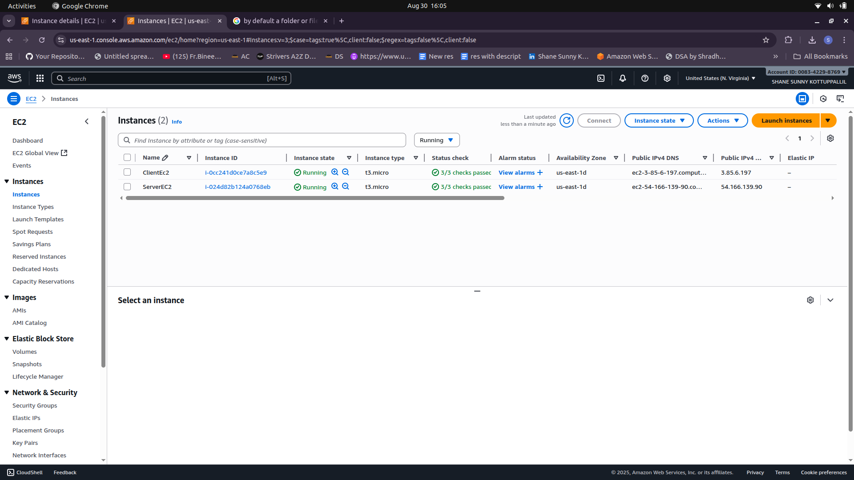

2) Prepare both machines (SSH + basics)

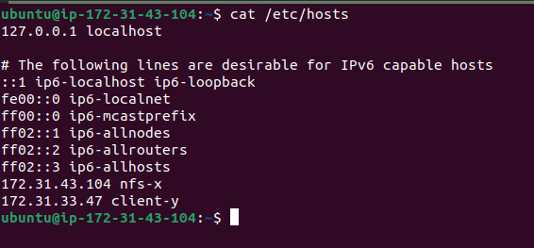

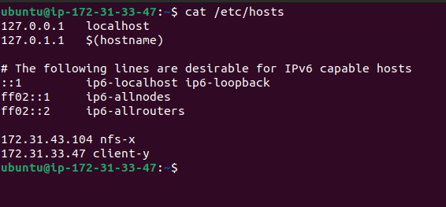

sudo apt update && sudo apt -y upgrade

3) Install NFS software

Server X:

sudo apt install -y nfs-kernel-server

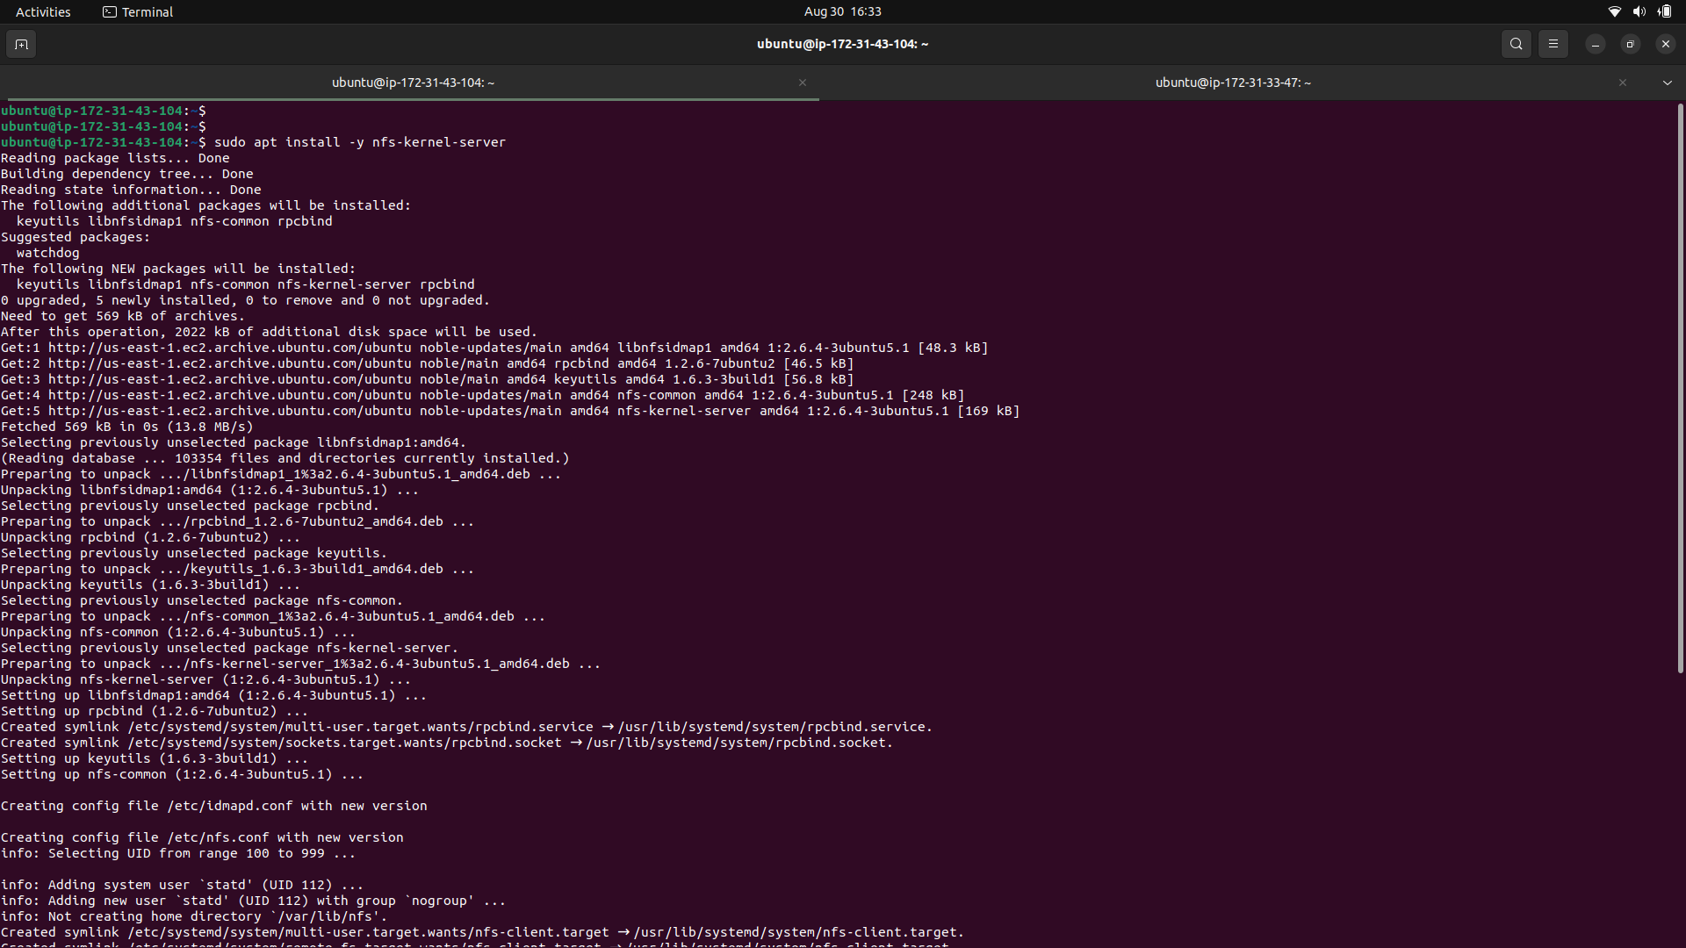

Client Y:

sudo apt install -y nfs-common

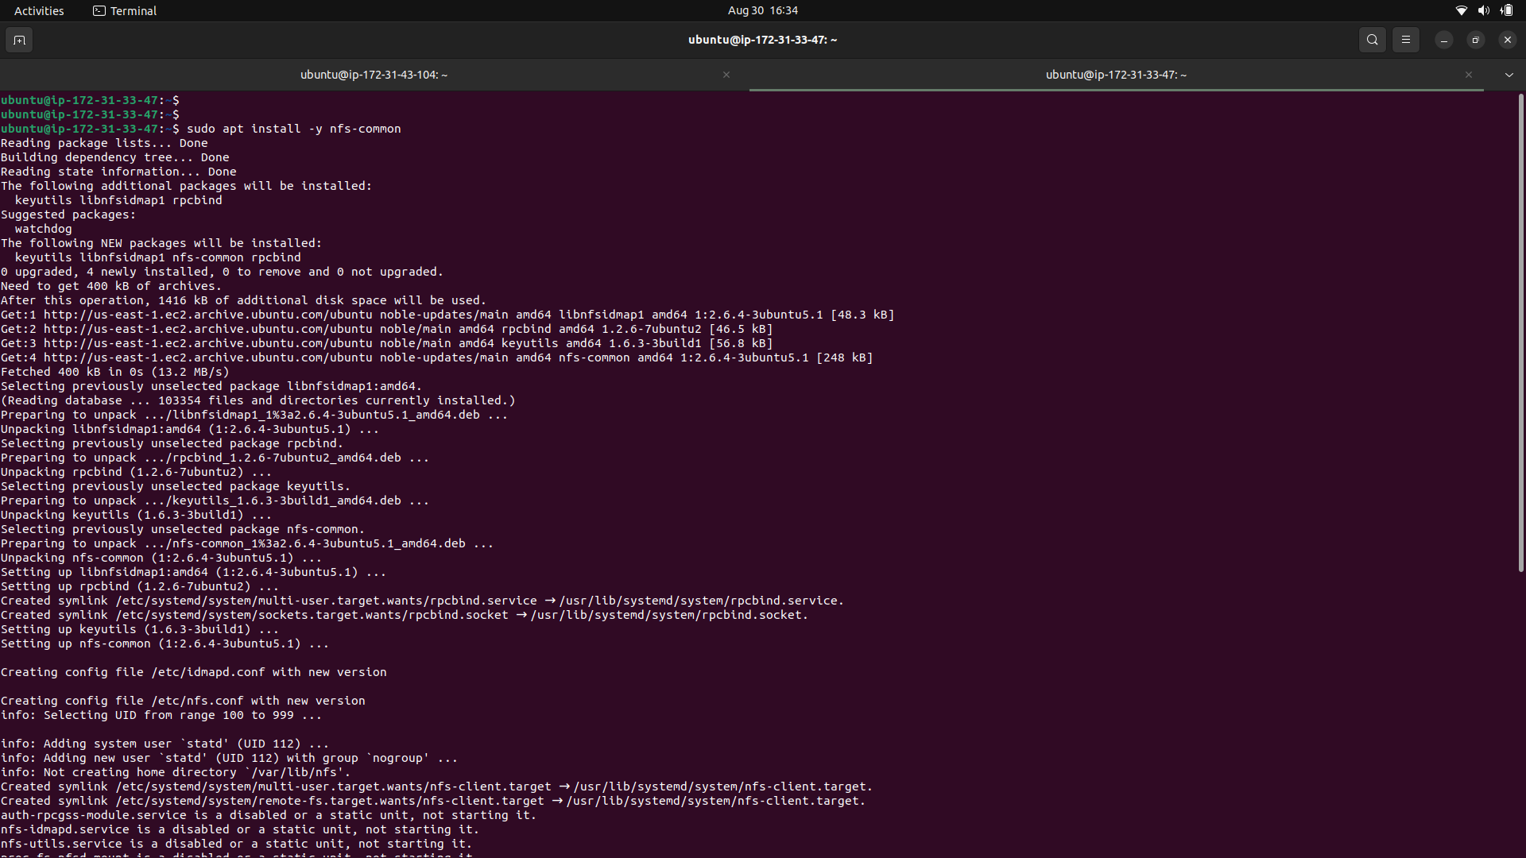

# On Server X

sudo mkdir -p /sample

sudo chown nobody:nogroup /sample

sudo chmod 0777 /sample



sudo nano /etc/exports

/sample 172.31.33.47(rw,sync,no_subtree_check,root_squash)

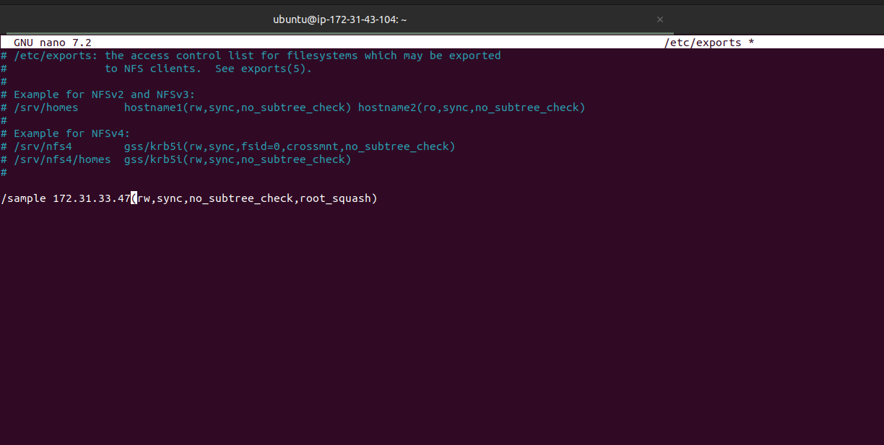

sudo exportfs -rav # activate the new rule set

sudo exportfs -v # show effective exports and options

sudo systemctl enable --now nfs-kernel-server

sudo systemctl status nfs-kernel-server --no-pager

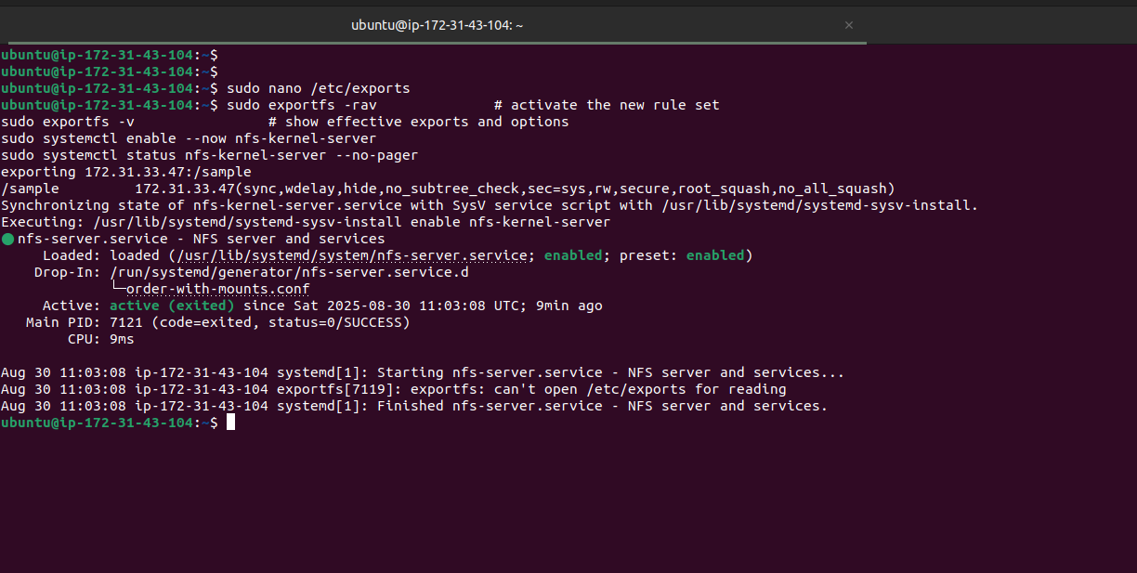

# On Client Y

sudo mkdir -p /mnt

# using server hostname (needs /etc/hosts line we added) or use the private IP

sudo mount -t nfs -o vers=4 nfs-x:/sample /mnt

# or:

# sudo mount -t nfs -o vers=4 10.0.1.10:/sample /mnt

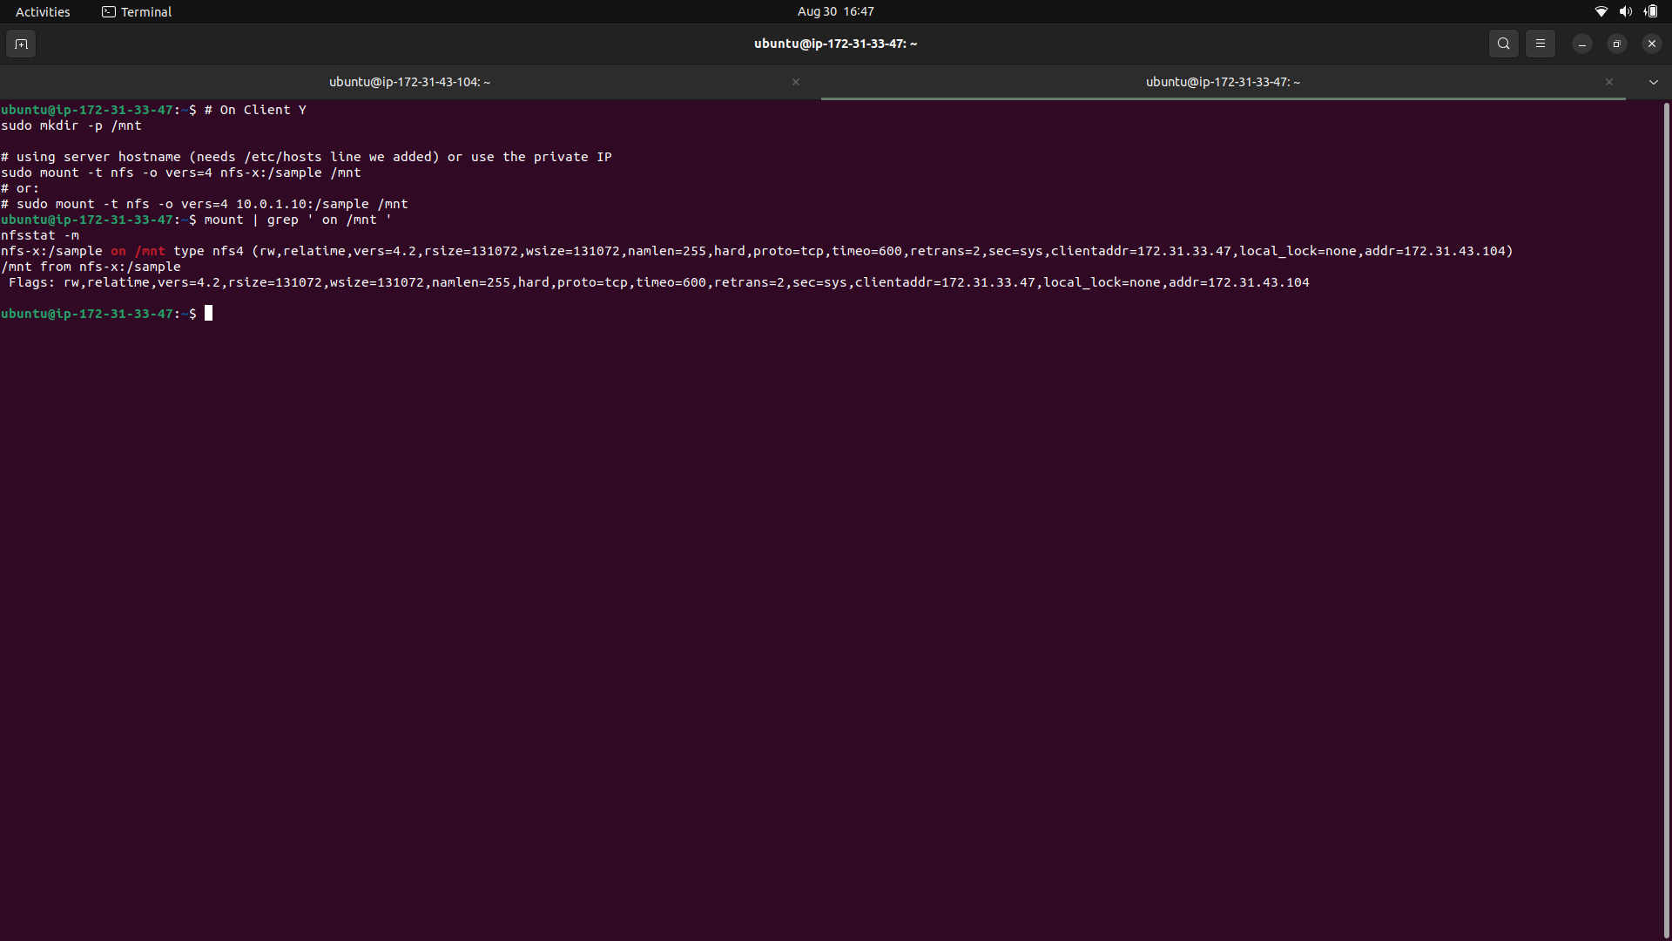

Mount the export on Client Y

# On Client Y

sudo mkdir -p /mnt

# using server hostname (needs /etc/hosts line we added) or use the private IP

sudo mount -t nfs -o vers=4 nfs-x:/sample /mnt

cd /mnt

mkdir testdir

echo "hello from client" | tee testdir/hello.txt

ls -l testdir

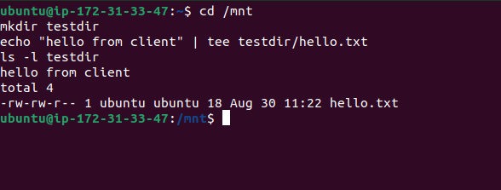

Make the mount persistent across reboots (Client Y)

sudo nano /etc/fstab

nfs-x:/sample /mnt nfs4 defaults,_netdev,vers=4.2,proto=tcp,hard,timeo=600,retrans=2 0 0

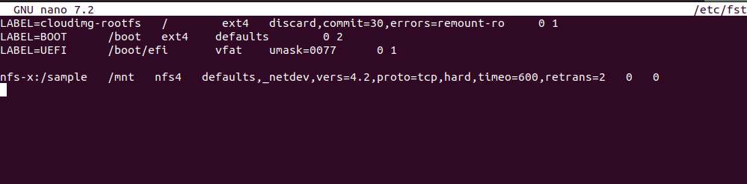

Check changes made by Client Y on Server-X

ls -ld /sample

ls -l /sample

